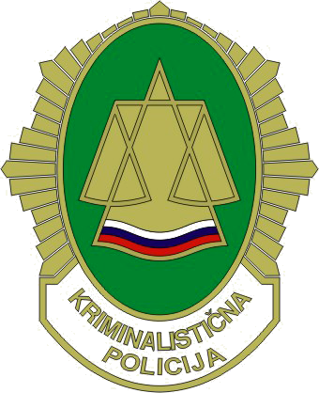
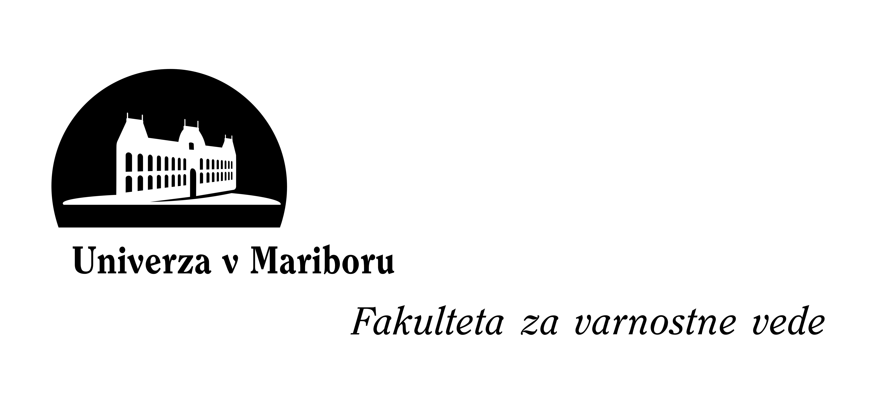
course Curriculum

»Art Crime Investigation«
13 – 14 October 2010
Faculty of Crimial Justice and Security, University of Maribor, Ljubljana, Slovenia

Organiser/host: | SLOVENIA – Ministry of the Interior, Slovenian Police, General Police Directorate, Criminal Police Directorate;  University of Maribor, Faculty of Crimial Justice and Security;
Number of participants: 50 | Police officers and criminal investigators responsible for the fight against crime, if possible with particular regard to art crime and trafficking in stolen works of art; experts and trainers in the field.
Overall aim: | […]
Objectives: | - To analyse the phenomenon of national and international art crime and trafficking in stolen artworks and their major connections.  - To assess the potential threat from stolen artwork trafficking with a view to exploring prevention strategies.
Methods: |  | Lectures  Assignments  Discussions |  |  | Group Work  Case Study  Simulation
Pre-course assignments: |  | Yes  No |  | If Yes:  Estimated No. of Study Hours: |  |  | [...]
Additional language to English: | […]
Duration: | No. of Days: |  | 2 | Total No. of Training Hours: |  | 11

Please send the document to ursula.belaj@policija.si till 10 September 2010.

