
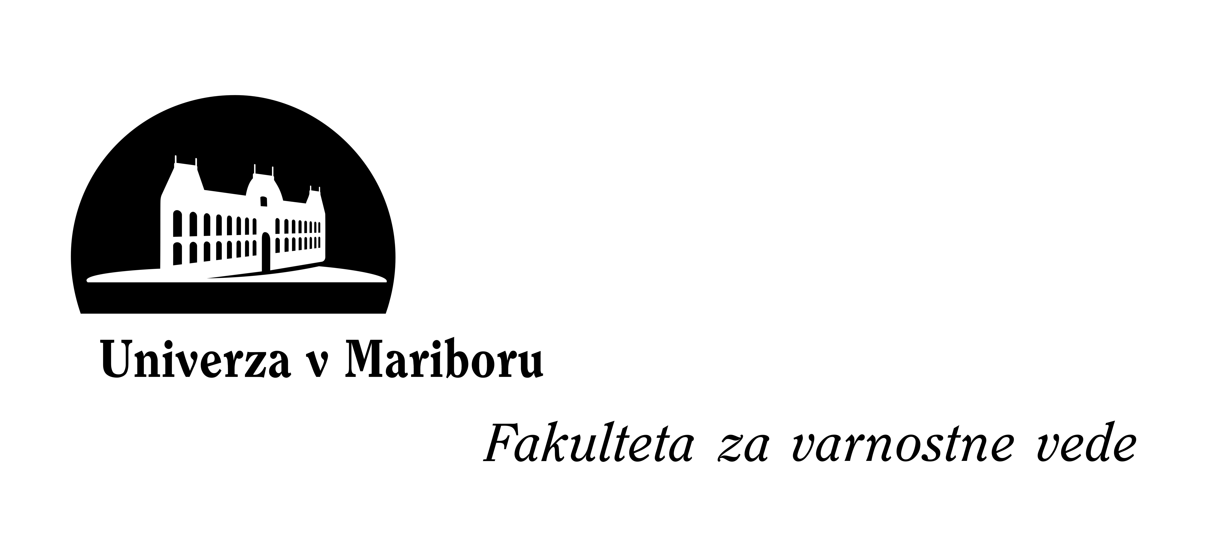 INFORMATION ON LOGISTICS

»Art Crime Investigation«
13 – 14 October 2010
Faculty of Crimial Justice and Security, University of Maribor, Ljubljana, Slovenia

Organising country/college: | SLOVENIA |  | Ministry of the Interior, Slovenian Police, General Police Directorate, Criminal Police Directorate;  University of Maribor, Faculty of Crimial Justice and Security;
Course Manager | Name: Ursula BELAJ  Office: +386 1 428 53 15  Name: Bojan DOBOVSEK Ph. D.  Office: +386 1 300 83 43 |  | ursula.belaj@policija.si  bojan.dobovsek@fvv.uni-mb.si
Date and time of activity: | First day  Last day | Date: 13.10.2010  Date: 14.10.2010 | Start time: 10.00  End time: 14.00
Venue address:  Phone and fax of venue: | Faculty of Crimial Justice and Security |  | Kotnikova 8, Ljubljana  +386 1 3008 300
Airport/railway: | Nearest airport(s):  Nearest railway station: |  | Ljubljana Joze Pucnik Airport  Ljubljana
Transfer information from the airport to the course venue: | Unfortunately we can not provide you the transfer from the airport to the hotel or Faculty. But at the airport are numerous public transportation connections from the airport to the capital city Ljubljana.
Accommodation details: | Accommodation expenses will be the responsibility of the sending countries. Accommodation, inclusive of breakfast, you have to arrange by yourself in two of suggested hotel (Hotel Park and City Hotel*).**
Costs for Associated, Candidate countries and EU Bodies: | Accommodation and meals expenses amount to € 100.00 per person per day.
Dress code: | Participants are not requested to wear uniforms. However, formal attire is requested during lessons and the closing ceremony
Working language: | English
Other information (Internet and leisure facilities): | […]
*if you choose the City Hotel you have to indicate this in the invitation response, because the reservation will be managed by our International police co-operation division
**you have to inform us in which hotel will you be staying, because the organizer will arrange the departure of participants from the hotel to the Faculty at 09.30 on the first day of conference

