
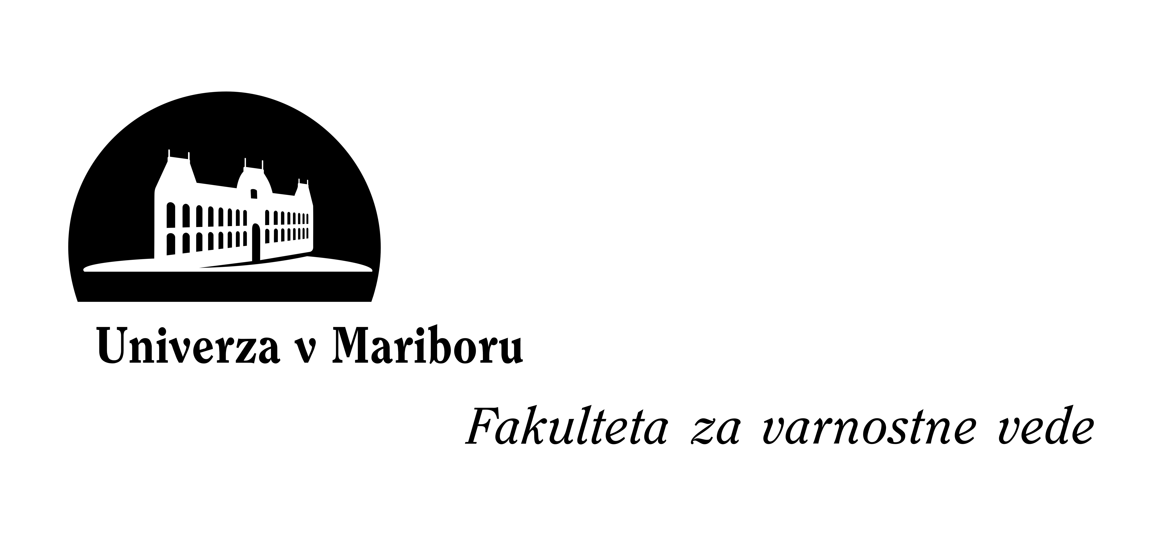 INVITATION RESPONSE

»Art Crime Investigation«
13 – 14 October 2010
Faculty of Crimial Justice and Security, University of Maribor, Ljubljana, Slovenia

Response sent in by:
Name: | […]
Country: | […]
Phone: | + […] | Fax: | + […]
Email address: | […]

We would like to nominate the following person:
First name: | […] | Last name: |  | […] |  | Title: | […]
Employer: | […]
Office phone: | [+…] |  | Mobile phone |  | [+…]
Email address: | […]

If there are vacancies, please grant admission to the following person(s) in order of preference:
1. First name: | […] | Last name: |  | […] |  | Title: | […]
Employer: | […]
Office phone: | [+…] |  | Mobile phone |  | [+…]
Email address: | […]
2. First name: | […] | Last name: |  | […] |  | Title: | […]
Employer: | […]
Office phone: | [+…] |  | Mobile phone |  | [+…]
Email address: | […]

The purpose of the international conference is the presentation of the current situation on the field of art crime, the exchange of experiences among participants and to get new knowledge, views of other countries in fight against art crime and getting ideas how to prevent trafficking of stolen artworks.

We expect that each participant will prepare the presentation of the current situation in their country on the discussing topic (10-15 min) and that participants will be sharing their knowledge and ideas related to the discussing with other participants.

If any participant country would like to present any practical examples from the discussing topic, please let us know, that we could include the presentation at the schedule.

Please return the completed form by 10 September 2010 to: ursula.belaj@policija.si.

