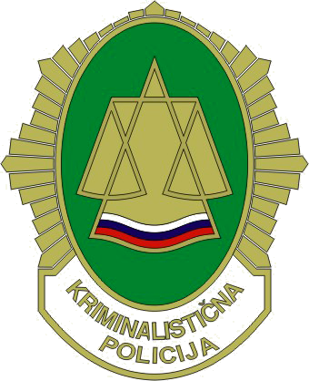
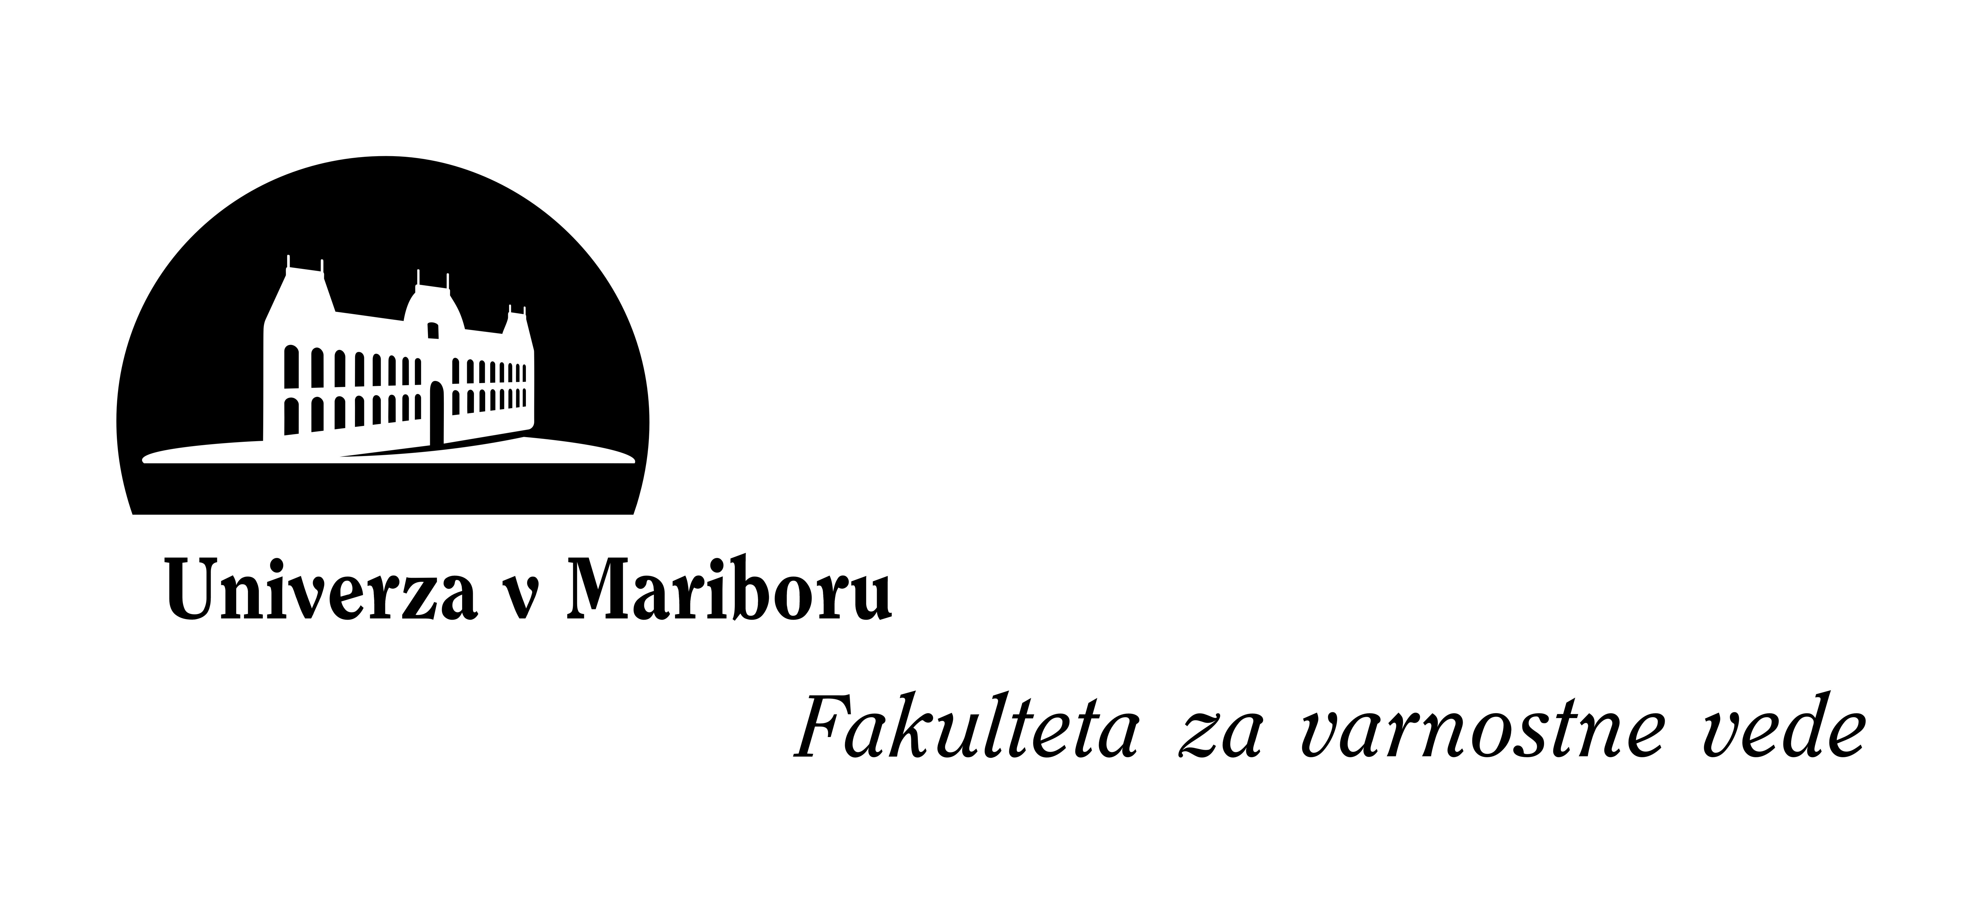

Programme of the international conference »Art Crime Investigation«
Ljubljana, 13. – 14. october 2010

Wednesday, 13 october 2010

10.00 – 10.30 Opening ceremony and welcome speech

10.30 – 11.15 Professional Paper; Faculty of Criminal Justice and Security

11.15 – 11.30 coffee break

11.30 – 12.15 Professional Paper; Faculty of Criminal Justice and Security

12.15 – 13.00 Competence of Slovenian Customs

13.00 – 14.00 Lunch break

14.00 – 14.45 Misdemeanor Jurisdiction of Culture and Media Inspectorate

14.45 – 15.30 Art Crime Prevention

15.30 – 15.45 coffee break

15.45 – 16.30 Art Crime in Slovenia and the Slovenian Stolen Works of Art Database

16.30 – 17.00 Presentation of the practical examples from Slovenian practice

17.00 – 18.00 dinner

18.00 – free time

Thursday, 14 october 2010

09.00 – 12.00 Workshop (presentations of the participant countries)

12.00 – 13.00 Presentations of practical examples (participant countries)

13.00 – 13.30 Closing ceremony

13.30 – Departure of participants

